1. Create a customized docker image by using Docker file.

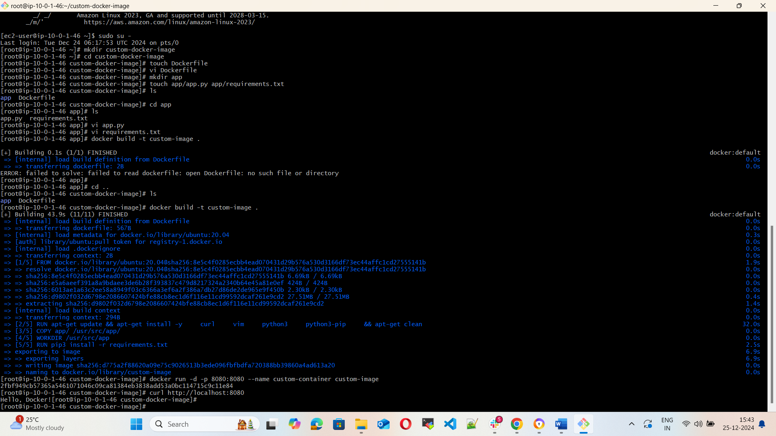

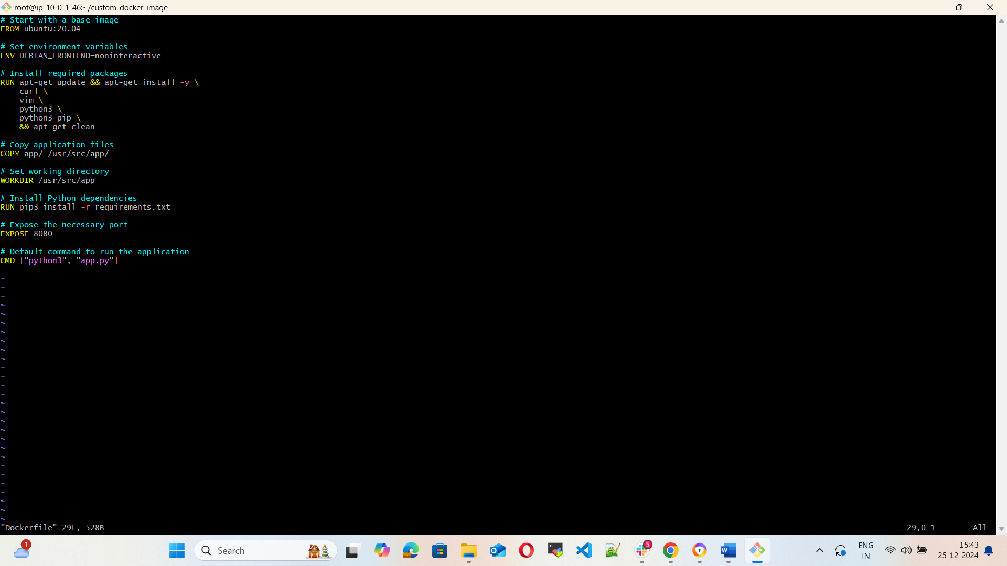

1. Push the image to docker hub

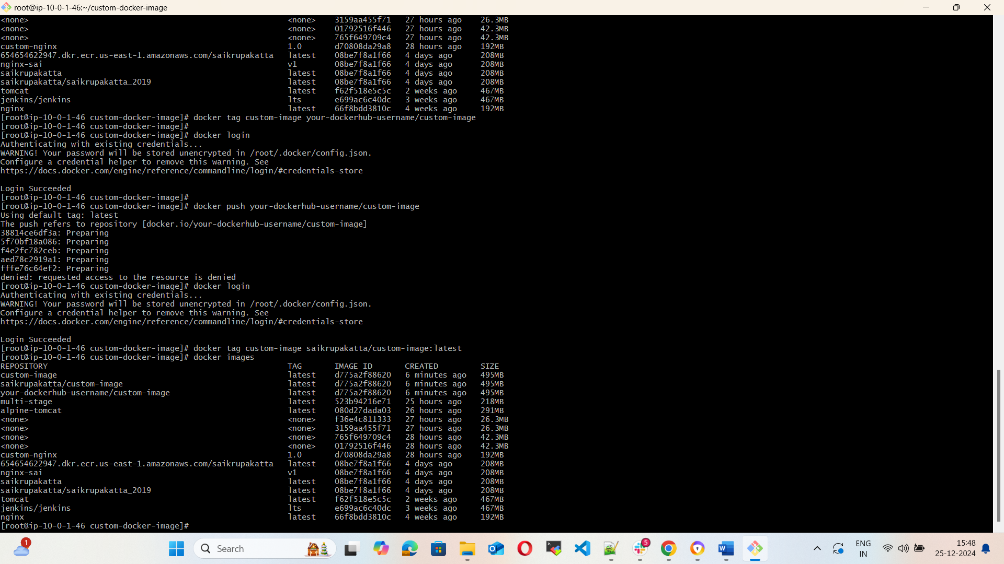

1. Push the same Image to Amazon ECR

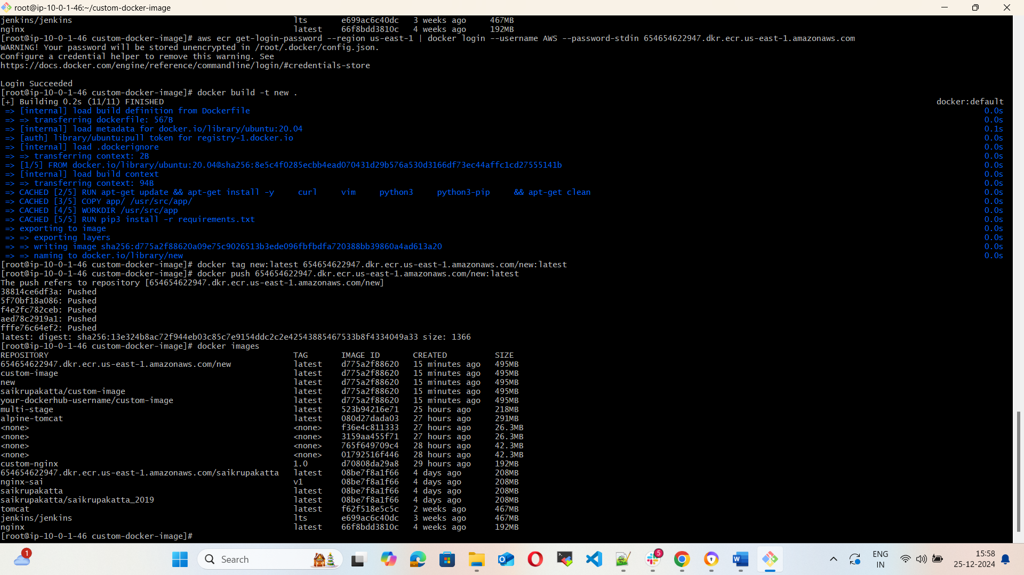

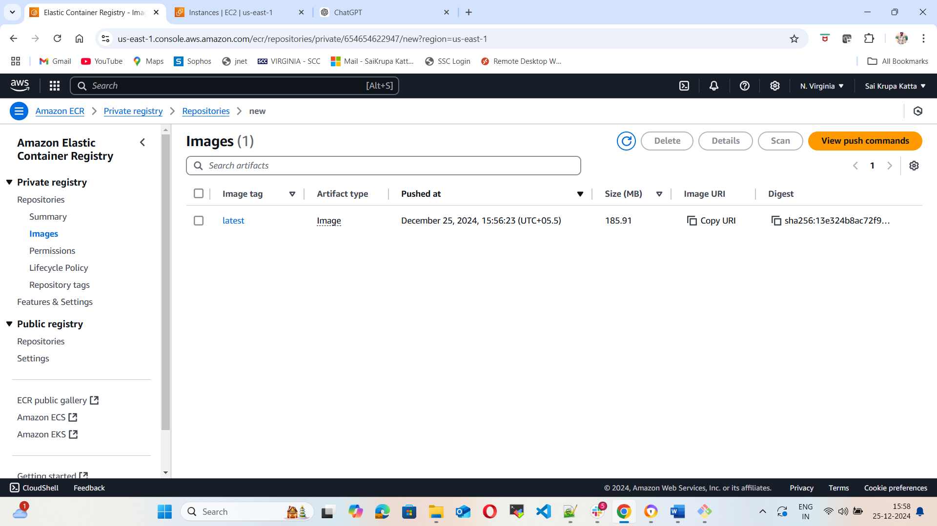

1. Provision one ec2 using terraform and install Jenkins.

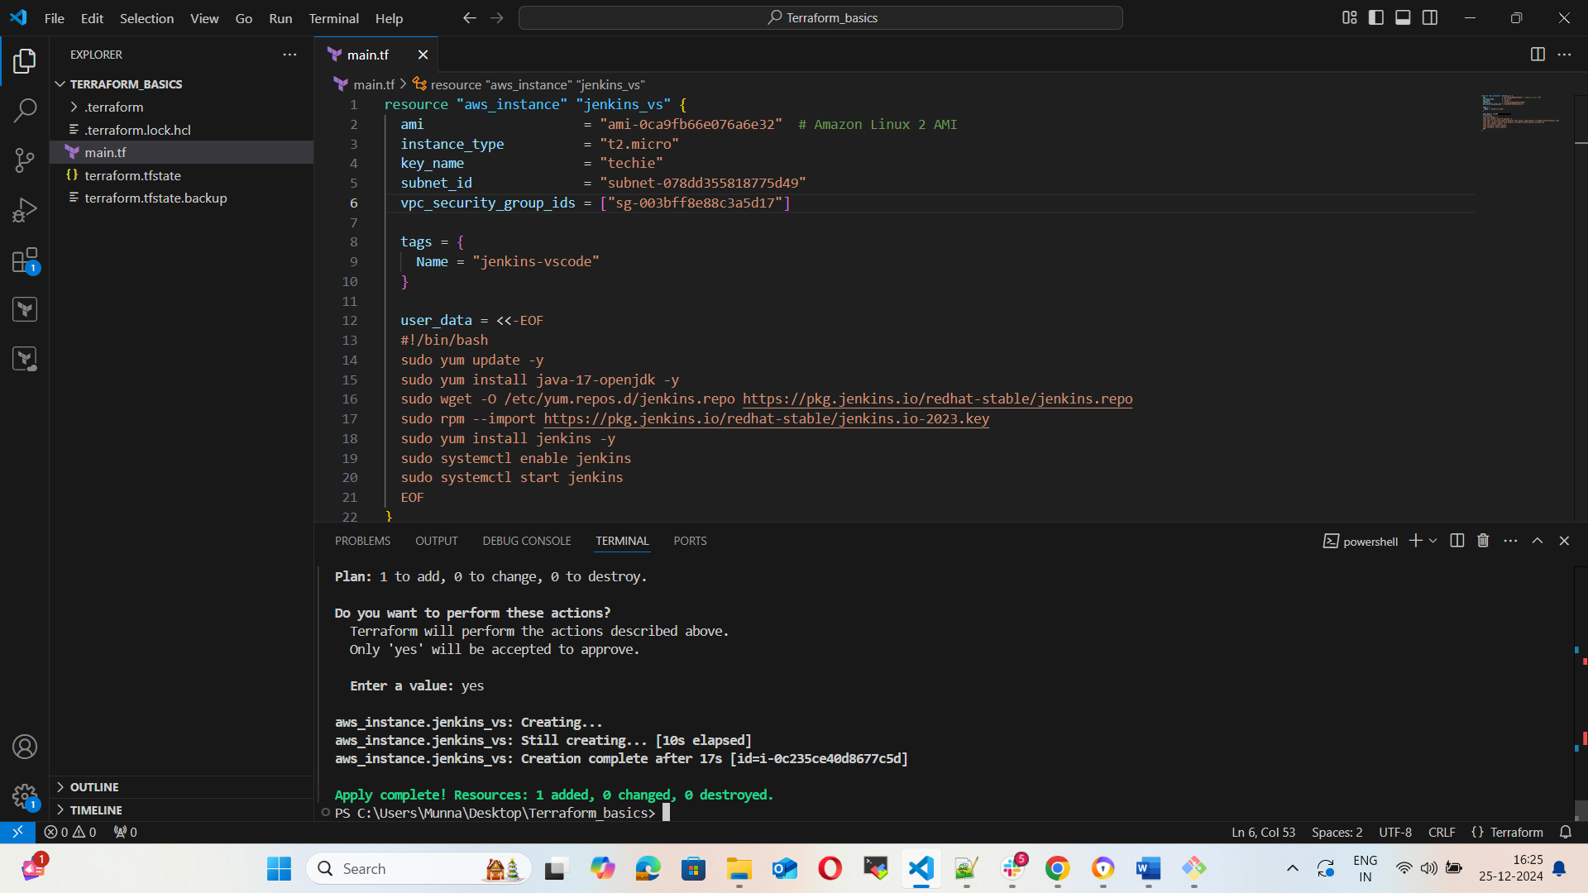

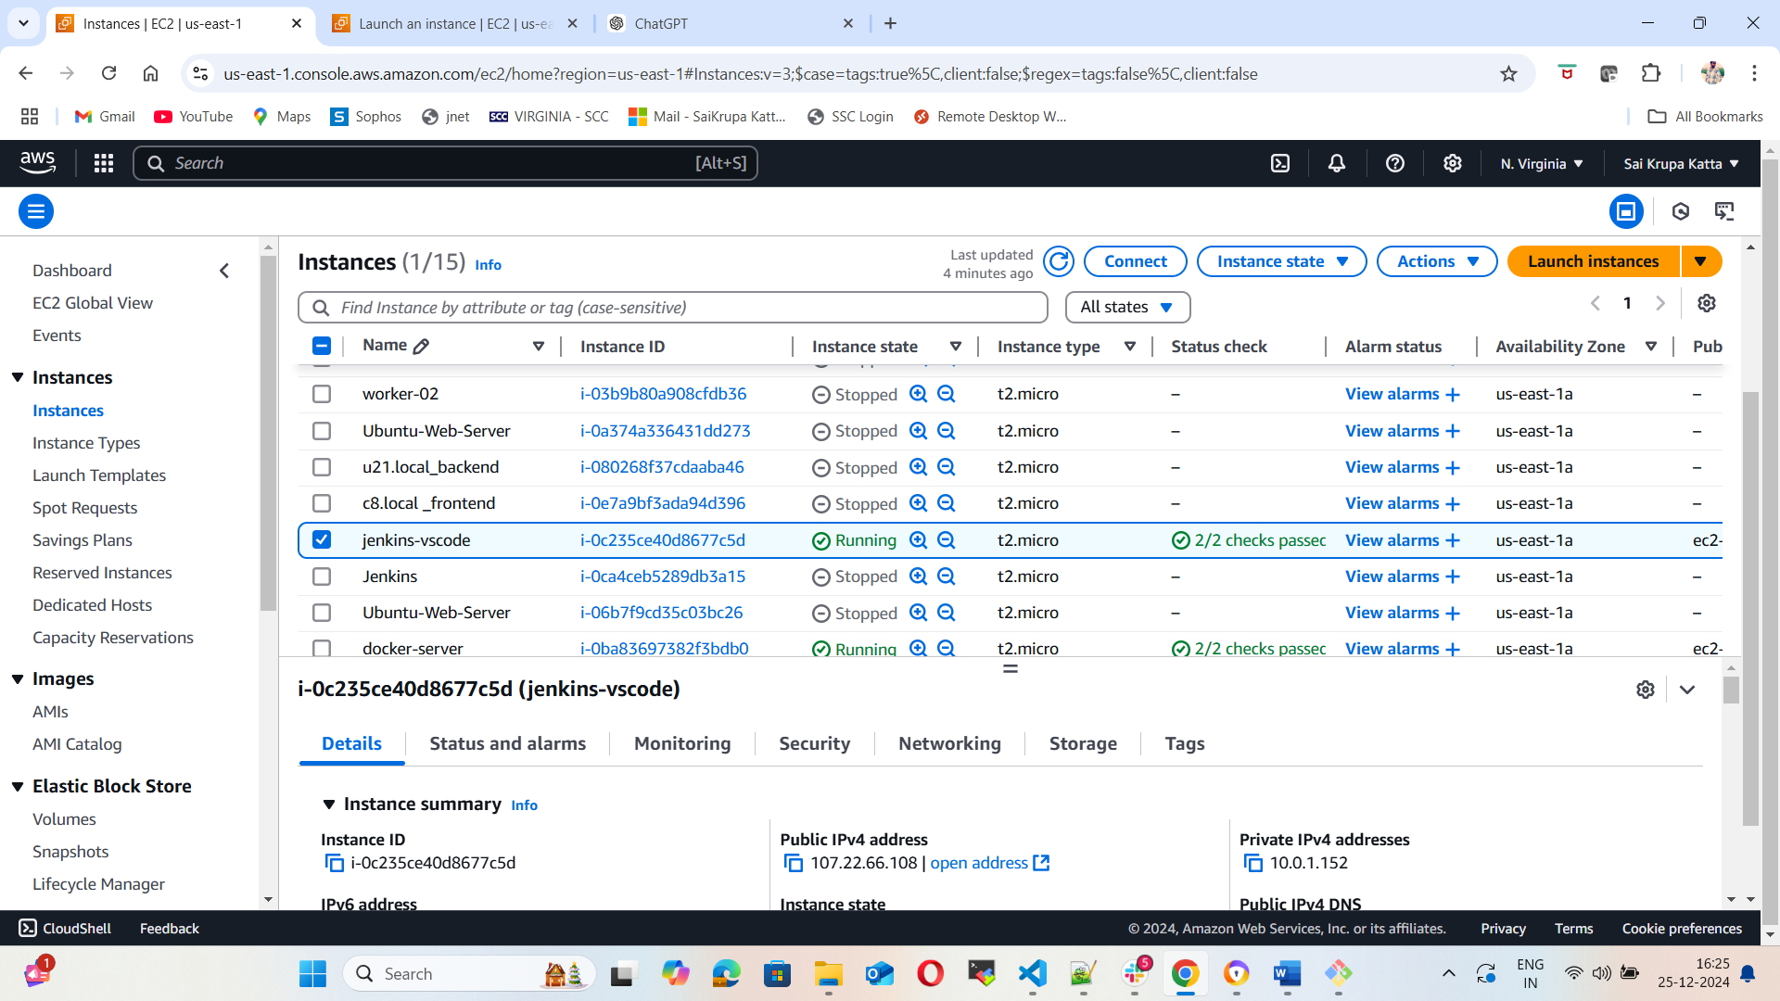

5) Create One Jenkins job to Build and push the Docker image to Docker Hub.

(<https://github.com/betawins/Python-app.git>)

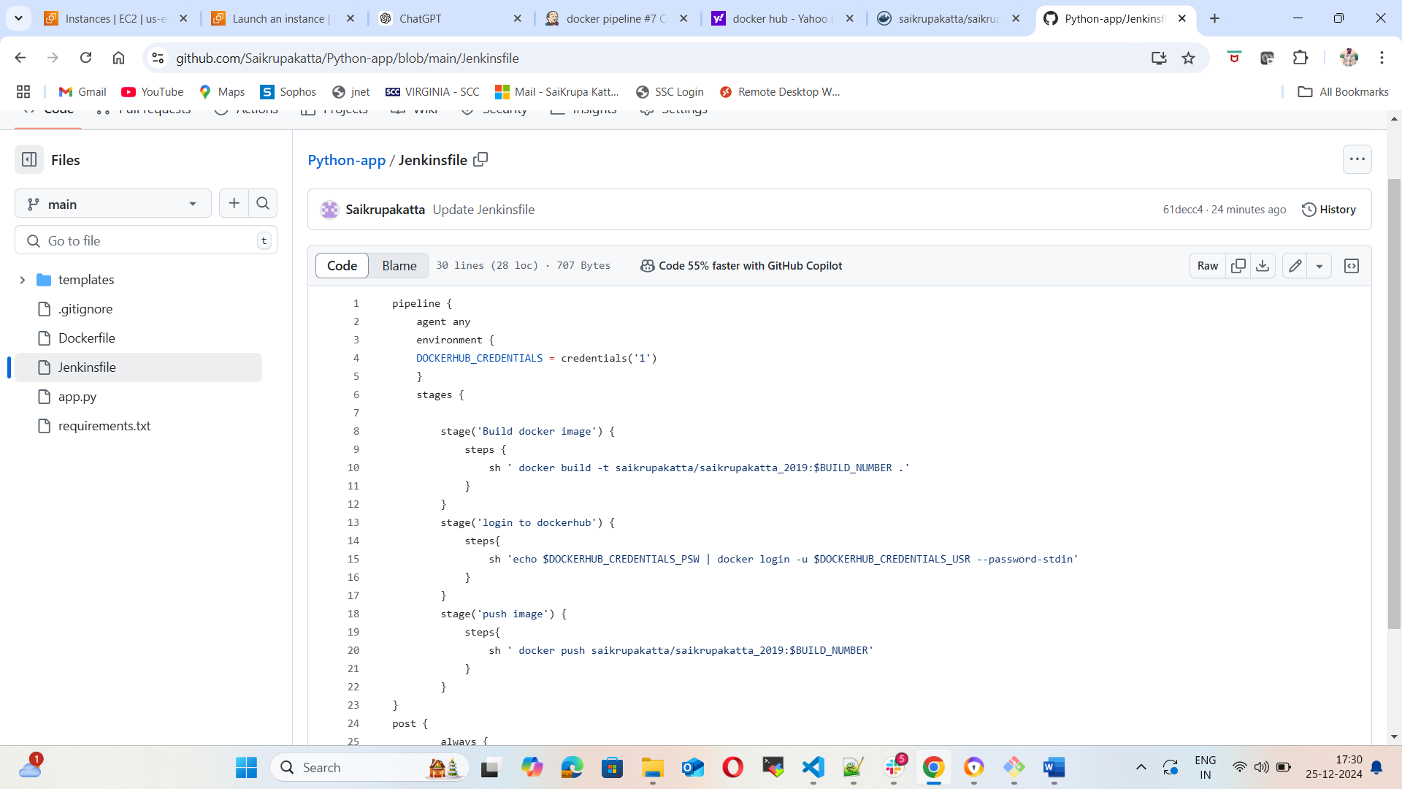

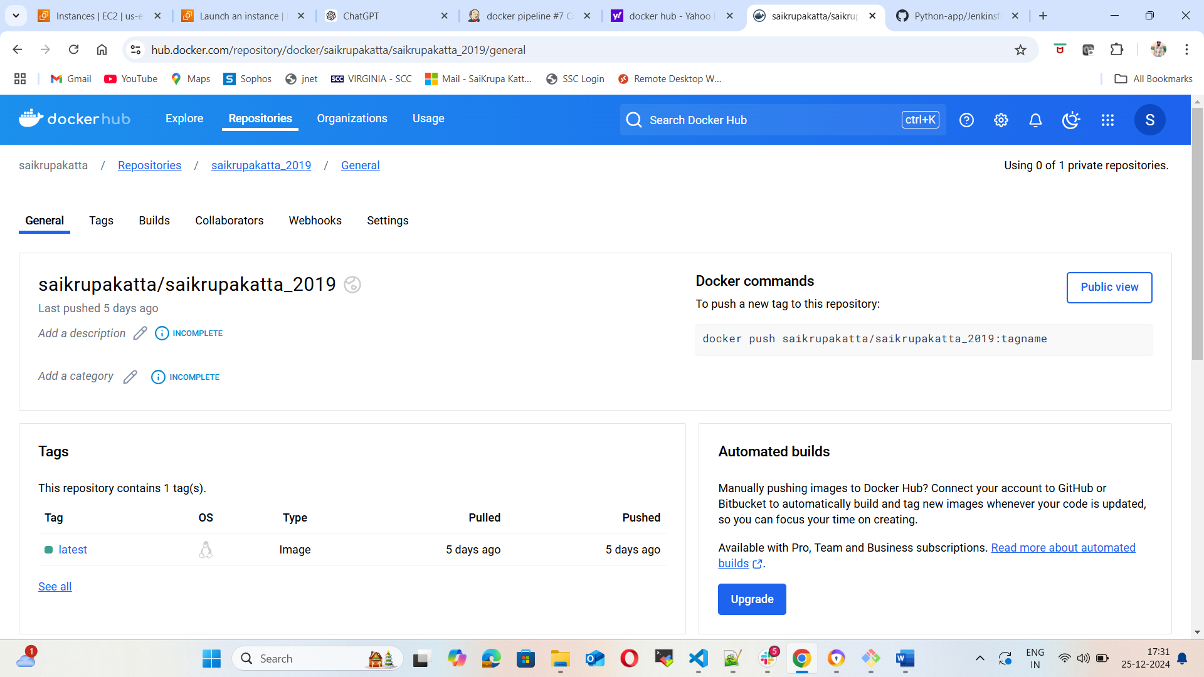

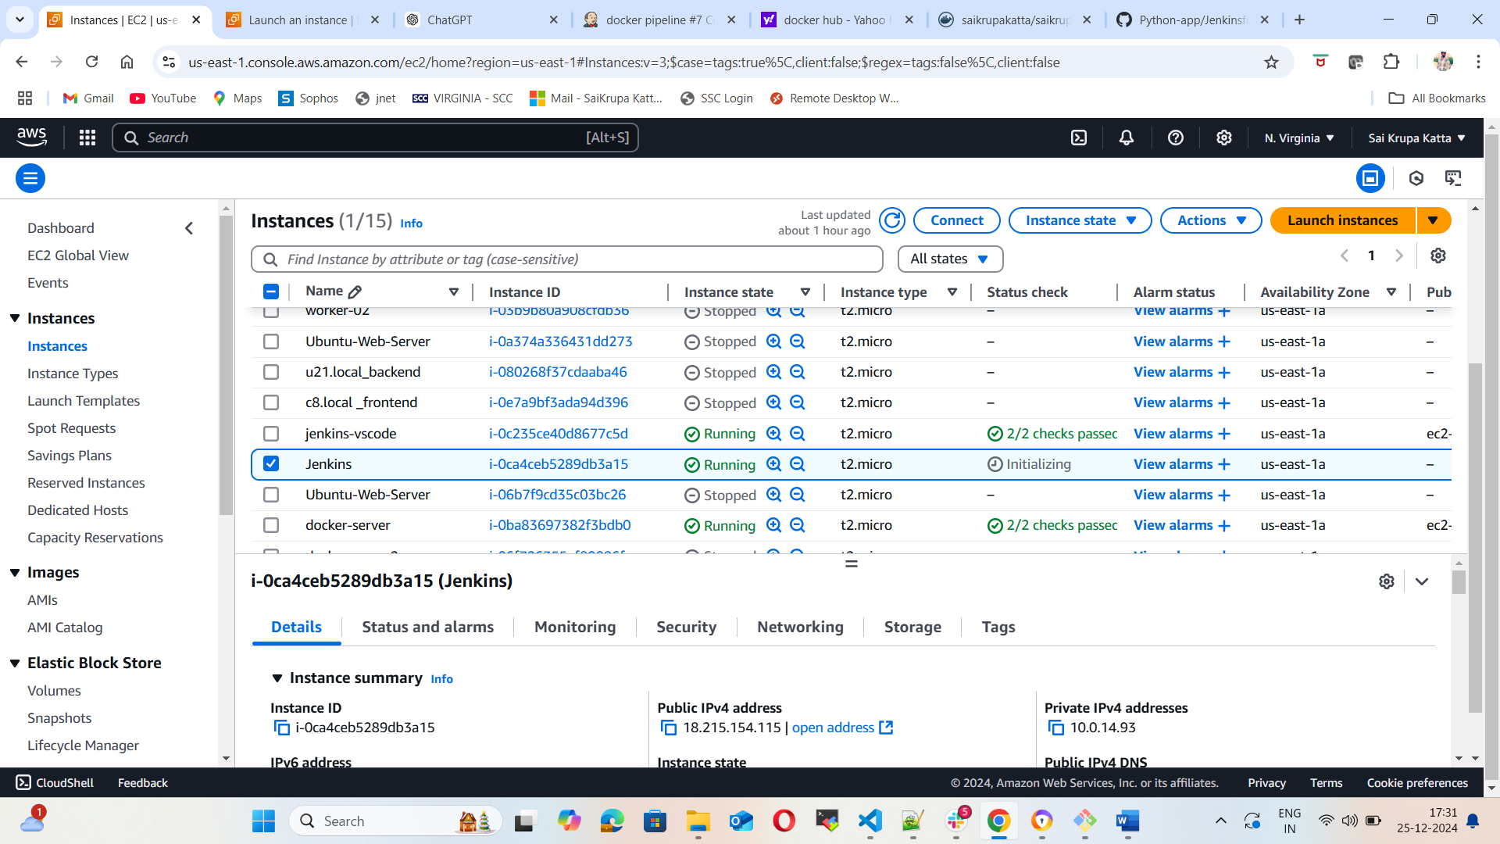

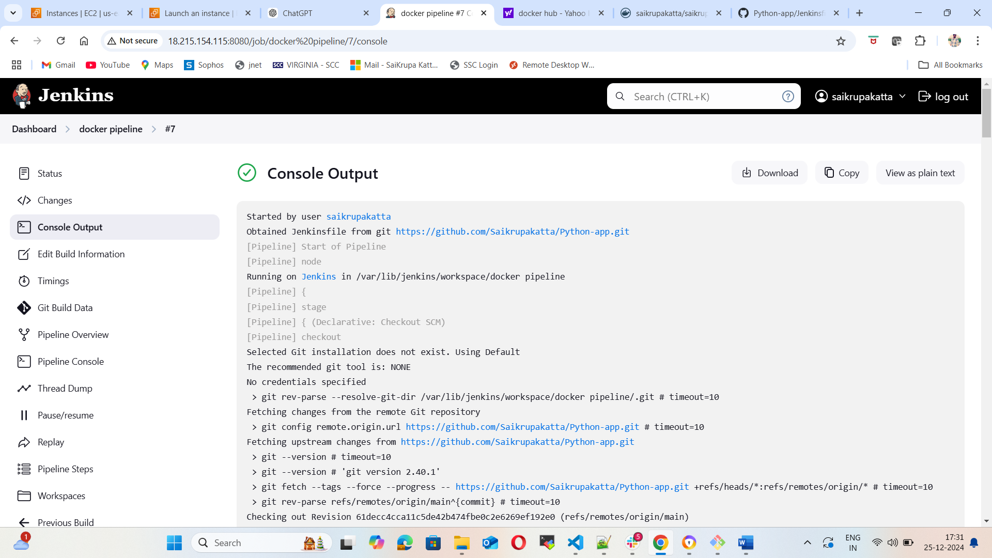

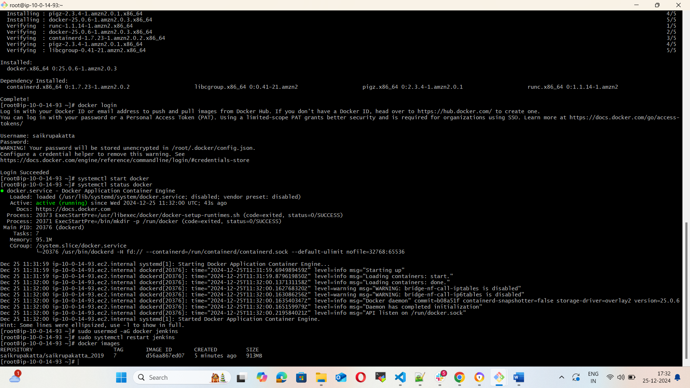

###############################################################################################

Source Code: https://github.com/betawins/docker-tasks.git

1. From the source code of the frontend, using that write a Docker file & build a docker image, run & push that image to your docker registry

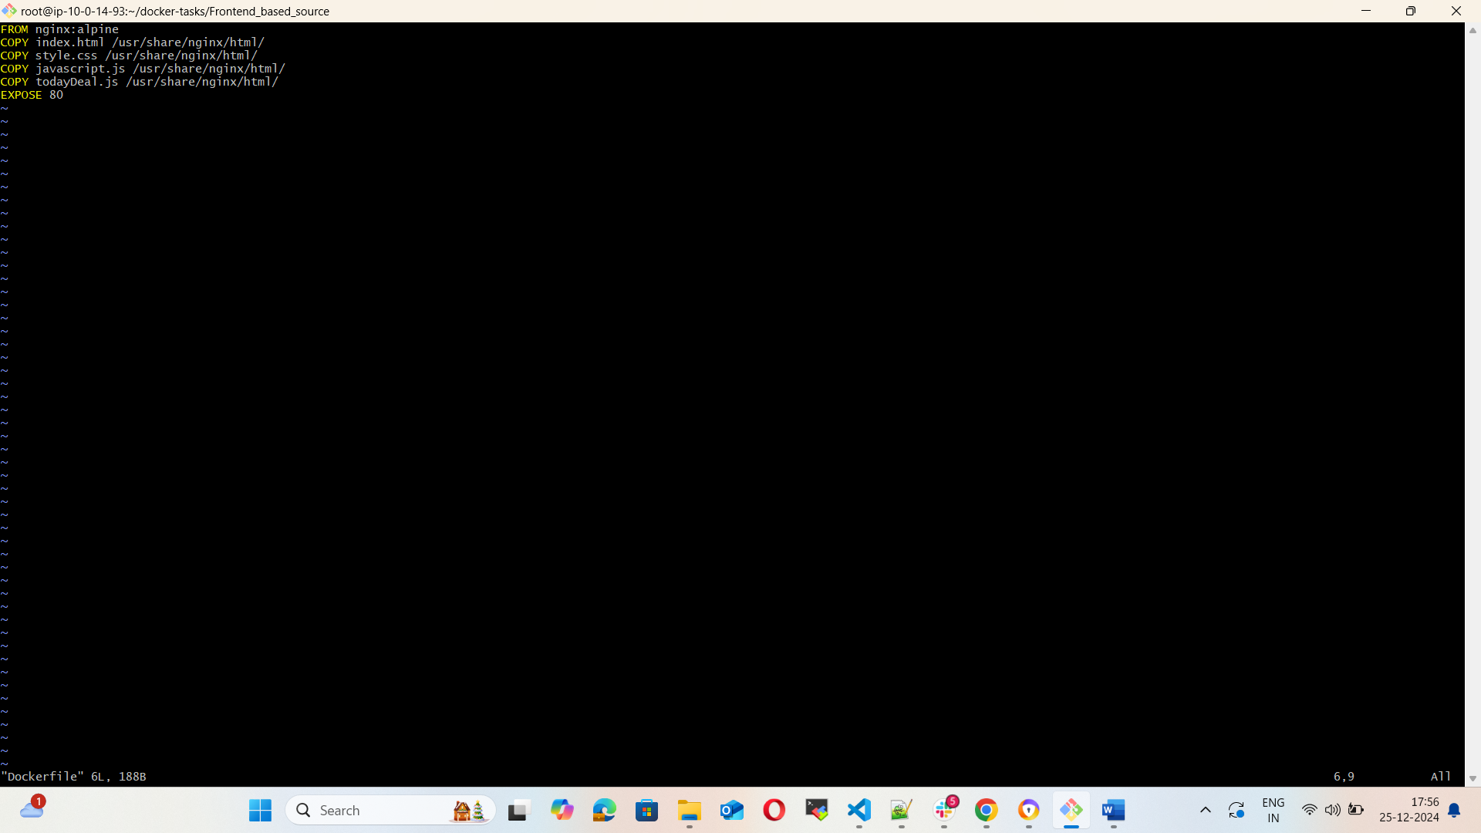

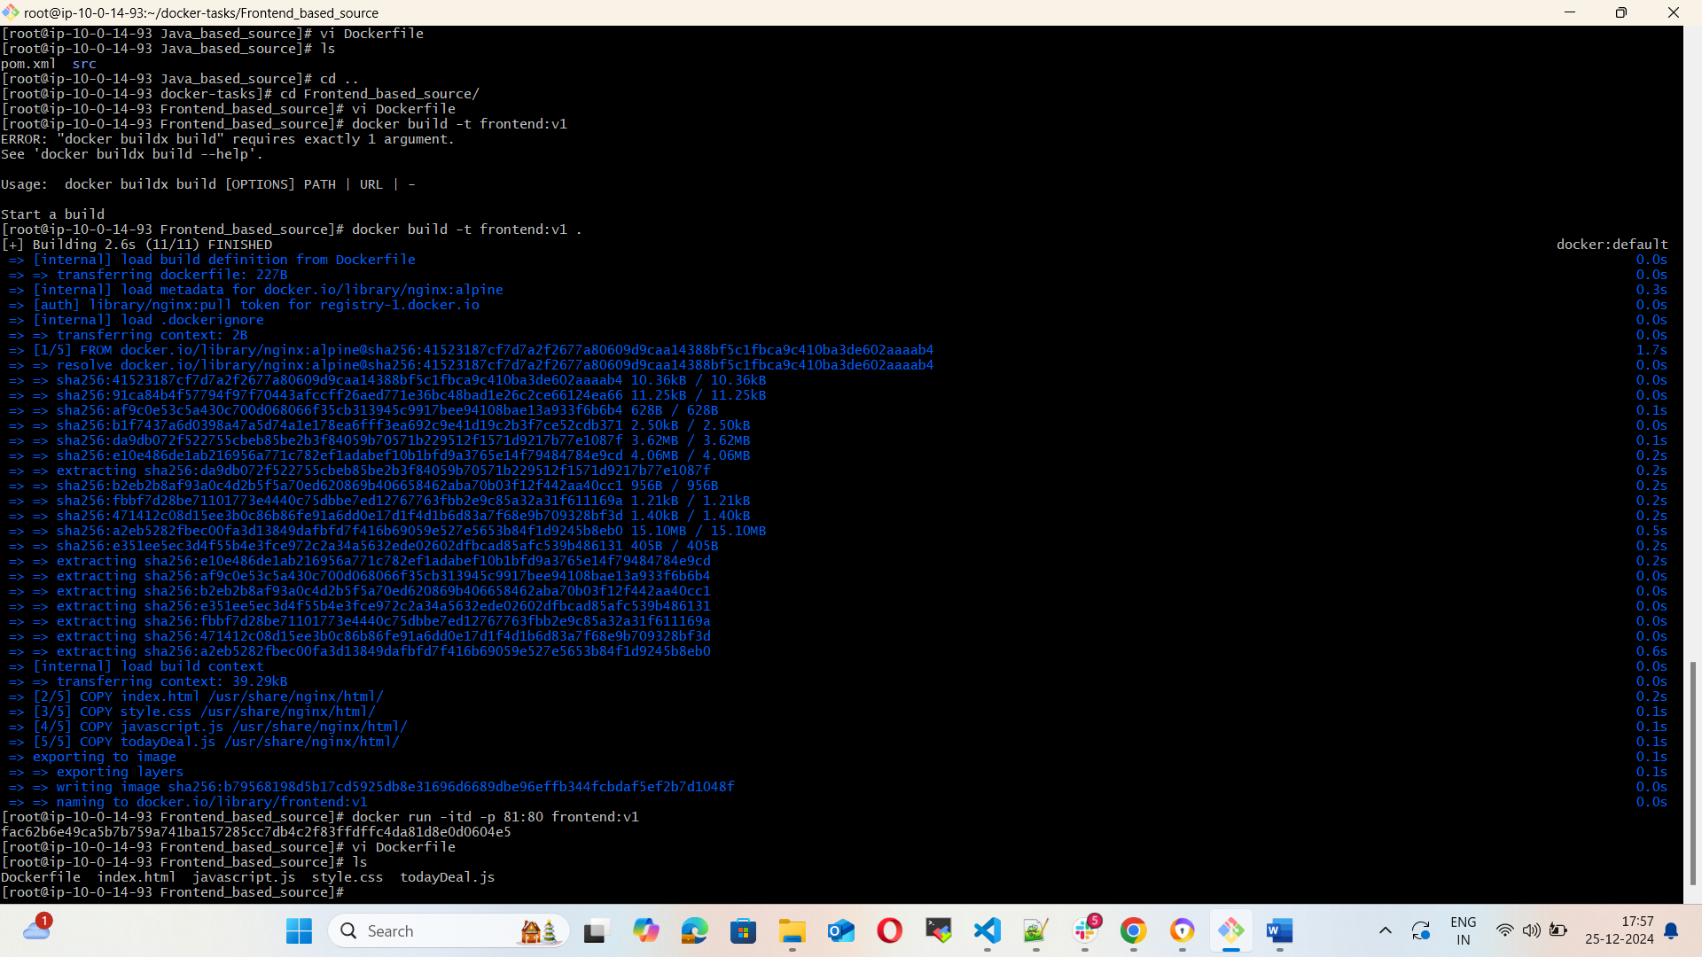

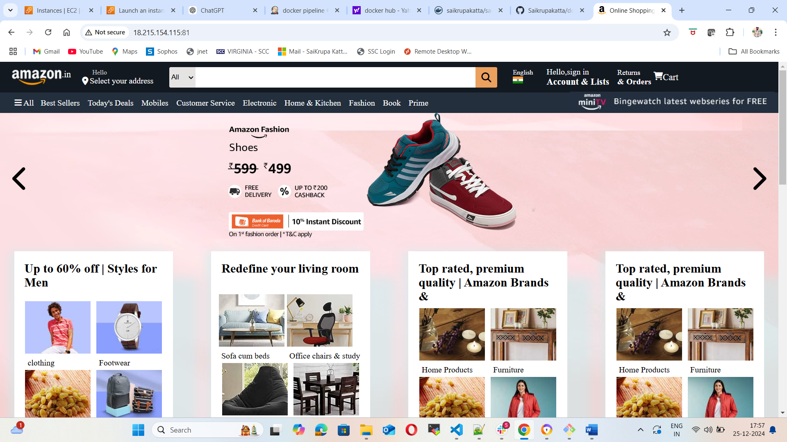

1. From the Java Based Source Code, write a Docker file, build, run & push to docker registry.

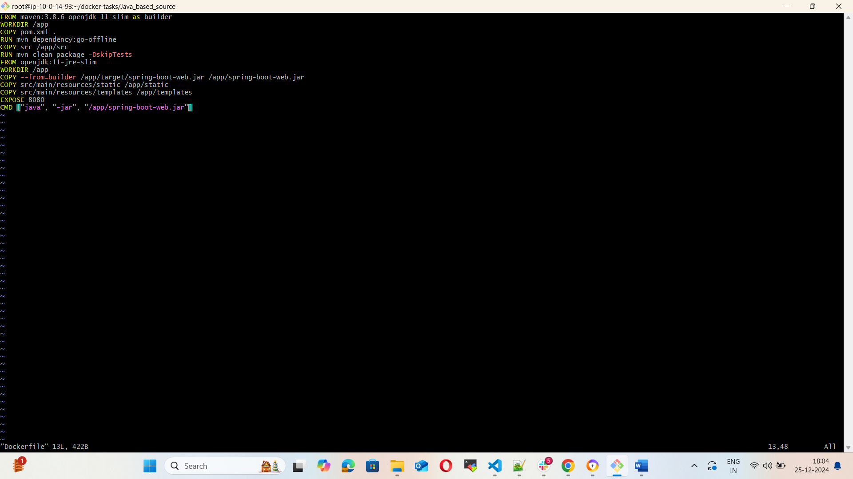

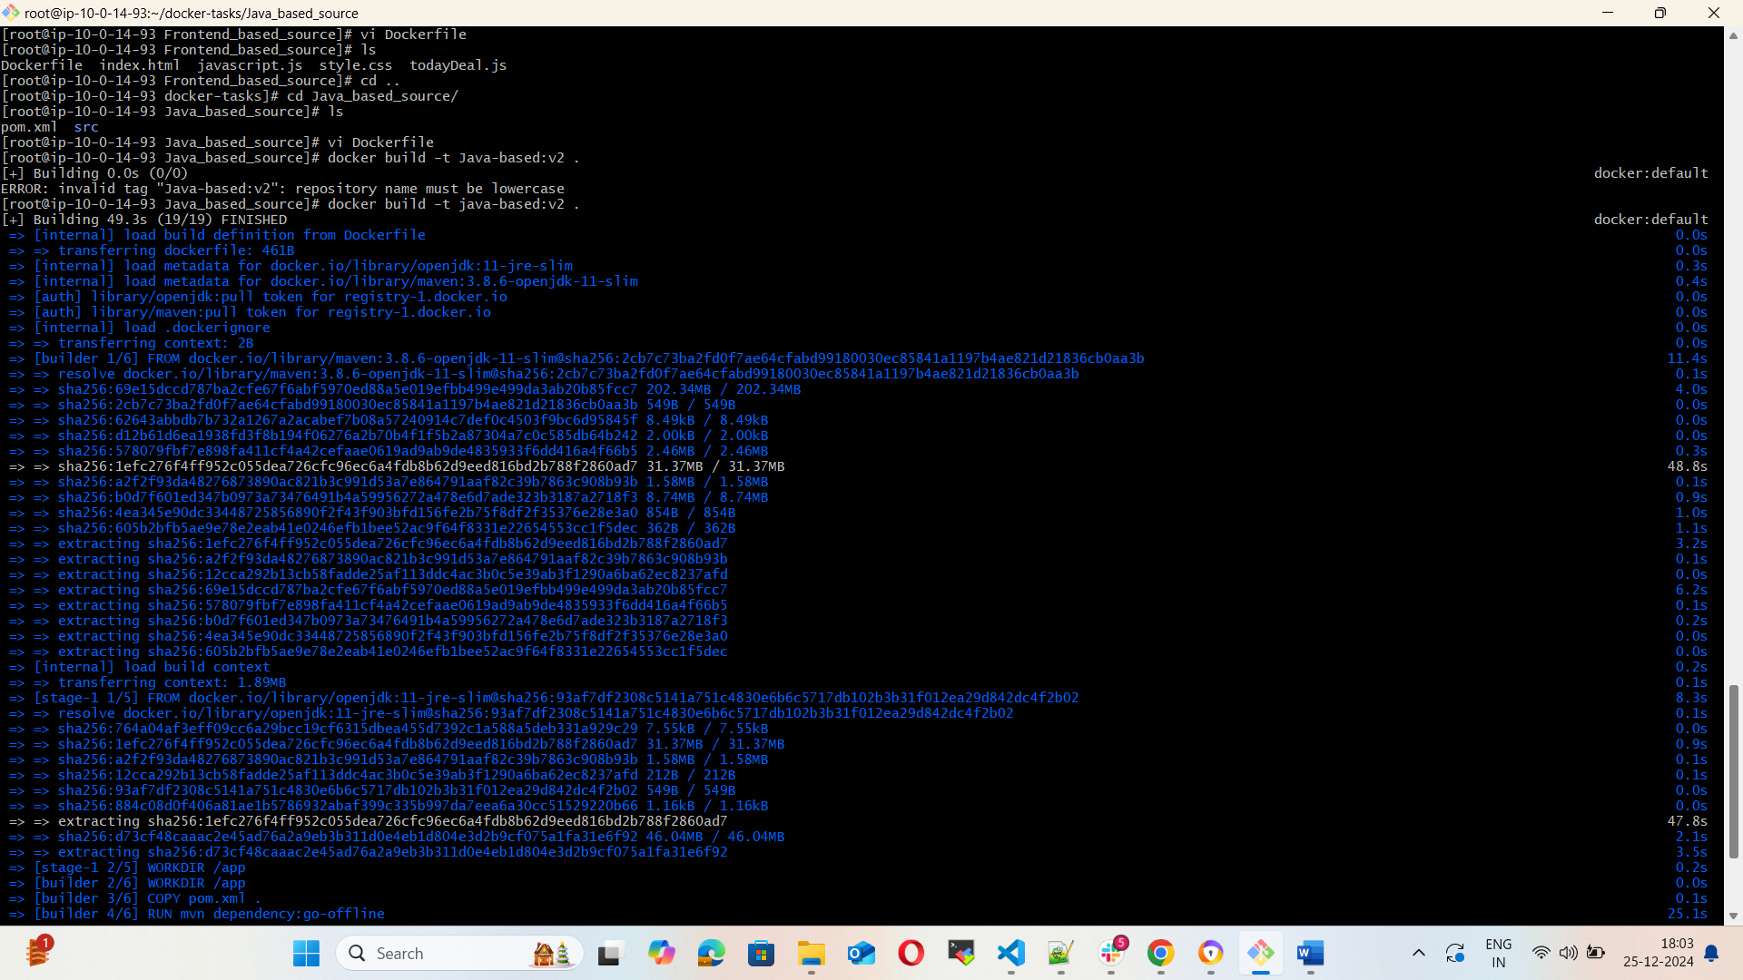

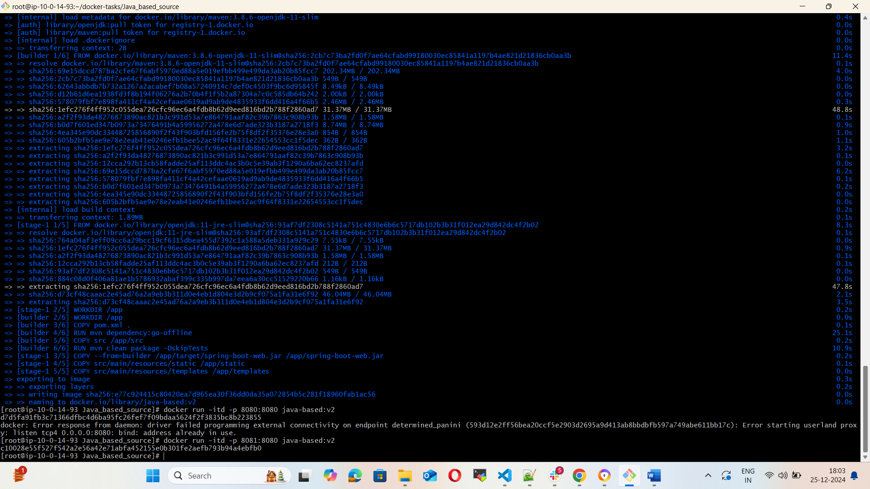

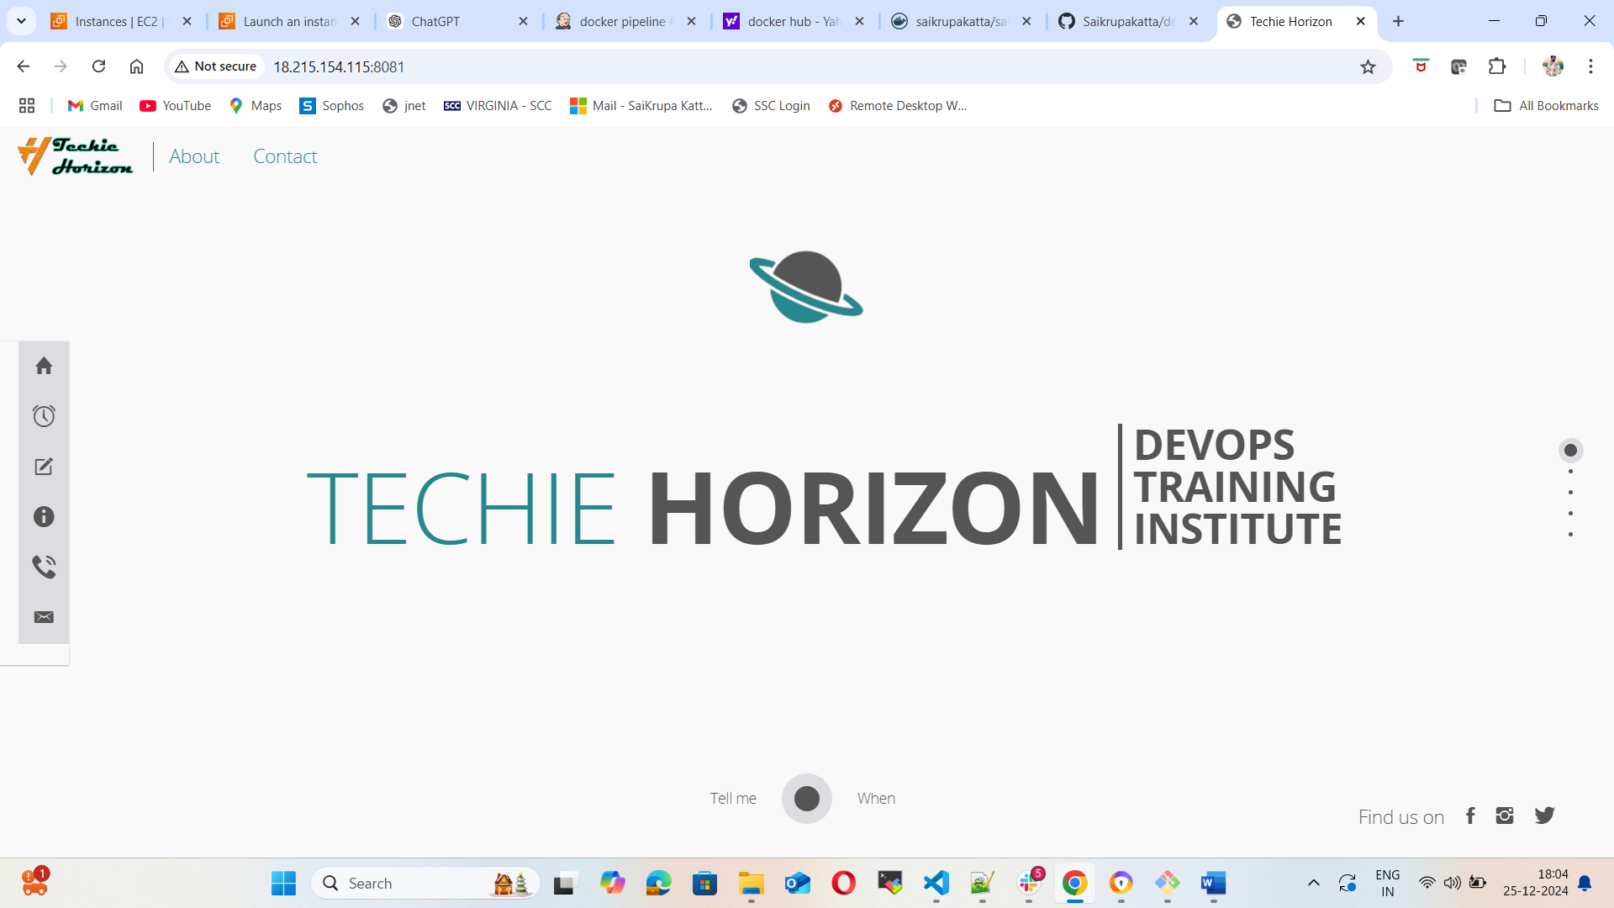

3. From the NodeJS Based Source Code, write a docker file, build with tag v1, run & push to docker registry.

4. Write a docker-compose docker file to setup WordPress with MySQL database